Title: Does Wearing a Bra Regularly Prevent Sagging Breasts?
Keywords: bra and sagging, breast firmness, women, breast ptosis, Cooper’s ligaments, bras and breast health, breast support, body image, sagging breasts causes, bra myths, women’s health
Short Description: Many women believe that wearing a bra even to sleep keeps the breasts firm and prevents sagging. But what does science actually say? This article breaks down the myths, the real causes of sagging, and how to care for your breasts the right way.

Does wearing a bra regularly prevent sagging breasts?
From our teenage years, most girls have heard the same thing: “Always wear your bra so your breasts won’t fall.”
Some women even say sleeping without one will make them sag faster. Over time, this belief has become so common that many women feel guilty or “careless” when they skip a bra, even for comfort.
But is that really how the body works, or is it just another health myth passed down through generations?
Let’s look at what actually causes sagging and whether wearing a bra every day truly makes any difference.
What Causes Sagging?
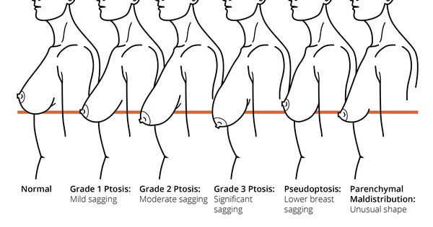
Let’s start with this: bras don’t make your breasts firm, and not wearing one doesn’t make them fall overnight either.
The truth is, sagging (or breast ptosis, as doctors call it) is a natural process that happens over time. It’s not a sign that something is wrong with your body.
Here’s what actually causes breasts to sag:
- Gravity: Over the years, gravity constantly pulls the breasts downward, especially when there’s little muscle or ligament support.
- Age: As we get older, the skin loses its elasticity, and the ligaments that hold the breasts in place stretch out.
- Pregnancy and breastfeeding: During these periods, breasts enlarge and shrink repeatedly, which can stretch the skin and ligaments.
- Weight changes: Gaining or losing weight quickly affects the fat and tissue around the breasts.
- Smoking: This reduces collagen and elasticity in the skin, speeding up sagging.
- Genetics: Some women are naturally more prone to sagging, depending on their skin type and breast structure.
Another thing to note is that:
Breasts don’t have muscles inside them; they’re made up of fat, glands, and connective tissue called Cooper’s ligaments.
When these ligaments stretch, the breasts begin to droop. A bra can support them, but it can’t stop this natural process completely.
What’s the Connection Between Bras and Sagging
There is no solid scientific evidence to support the notion that wearing a bra regularly prevents sagging.
One of the most talked-about studies on this topic came from Jean-Denis Rouillon, a French sports science researcher who studied hundreds of women over 15 years.
His findings suggested that women who didn’t wear bras actually developed stronger natural support in their breast tissue over time.
In simple terms, the body “learned” to hold the breasts up better when it wasn’t depending on a bra all the time.
That doesn’t mean every woman should throw her bras away. The study mainly showed that bras don’t stop sagging; they only provide temporary lift and comfort.
Here’s what other medical experts agree on:
- Sleeping with a bra doesn’t stop sagging; it just adds unnecessary pressure, and for some women, discomfort.
- The shape of your breasts won’t “train” or “set” based on whether you wear a bra or not.
When Wearing a Bra Is Actually Helpful
- When you have larger breasts: A well-fitted bra helps reduce shoulder, neck, and back pain caused by the extra weight. It also improves posture and prevents discomfort during daily activities.
- During exercise: Sports bras are a must for any physical activity, such as jogging, dancing, aerobics, because they minimize bounce and protect the delicate Cooper’s ligaments from strain.
- During pregnancy or breastfeeding: The breasts become heavier and more sensitive, so a soft, supportive maternity bra can help reduce pain and keep you comfortable.
- For personal comfort: Some women simply feel more confident or comfortable wearing a bra under certain outfits, and that’s perfectly fine.
Tips for Healthy, Firmer-Looking Breasts
Now that we know bras don’t stop sagging, let’s focus on what actually helps keep your breasts healthy and firm-looking over time.
Here are a few tips:
1. Keep your weight stable:
Constant weight gain and loss stretch the skin and ligaments around your breasts. Try to maintain a healthy, steady weight through balanced eating and exercise.
2. Exercise regularly:
While breasts don’t have muscles, strengthening the chest muscles underneath (like with push-ups, chest presses, and dumbbell flies) helps lift the overall appearance.
3. Stay hydrated and eat skin-friendly foods:
Water, fruits, and foods rich in protein and vitamin C (like oranges, eggs, and fish) support collagen production and skin elasticity.
4. Wear supportive bras when needed:
Especially during sports, pregnancy, or long days, not all the time.
5. Avoid smoking and excessive sun exposure:
Smoking reduces collagen and elasticity, while too much sun on the chest area can damage skin tissue.
6. Moisturize your chest area:
Gentle moisturizers or natural oils help keep the skin supple and prevent dryness that can make sagging look more noticeable.
Final Thoughts
Every woman’s breasts will change over time, and that’s okay. Firm or not, small or full, your breasts are a part of your body, not a measure of your beauty or worth.
In a world where we’re constantly told what our bodies “should” look like, it’s easy to forget that confidence comes from how we feel in our own skin, not from how others see us. What matters most is being healthy, comfortable, and kind to yourself as your body evolves.
So, whether you wear a bra or not, make the choice that feels right for you.
What do you think?
Have you ever been told one of these bras or sagging myths? Do you personally feel more comfortable wearing a bra all the time, or do you sometimes go without it?
Share your thoughts, let’s talk honestly about it.

Researched by Victoria Odueso

